Password Manager Installation Guide

v1.0, authored by David Frye, Fryeware LLC

# Server Installation Instructions

## System Requirements:

* Windows Server 2012R2 or newer
* 2 virtual CPU cores (minimum)
* 4 GB RAM (minimum)
* .NET Framework 4.6.2 or newer
* Joined to an Active Directory domain
* The Password Manager install media. This is available from the registered user Download page at the Fryeware web site: <https://www.fryeware.net>

## Procedure:

1. Install SQL Server Express 2016
   1. Download install media to a local directory on the server
   2. Run the installer (SQLServer2016-SSEI-Expr.exe)
   3. Select “**Basic**” from the installation type selection screen:

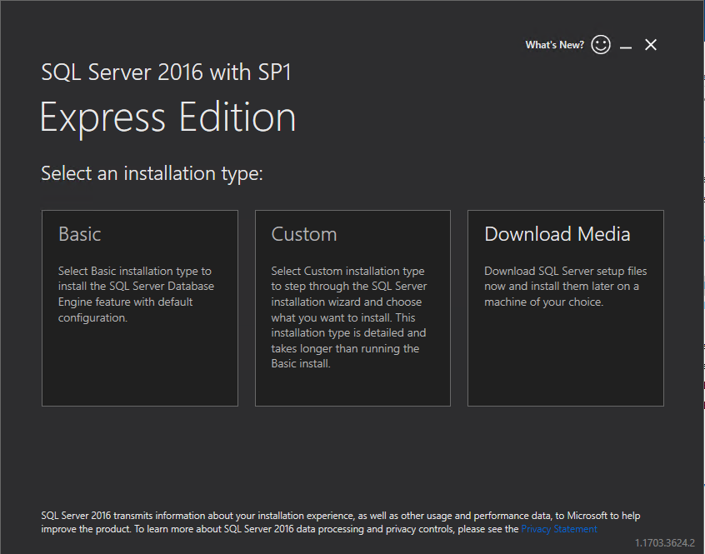

* 1. Accept all other defaults and complete the install. This may take 5- 10 minutes to complete at which point you should see a success notice.

1. Download the PMServer.msi to a local directory on the server and double click the PMServer.msi to begin the Password Manager server installation process.

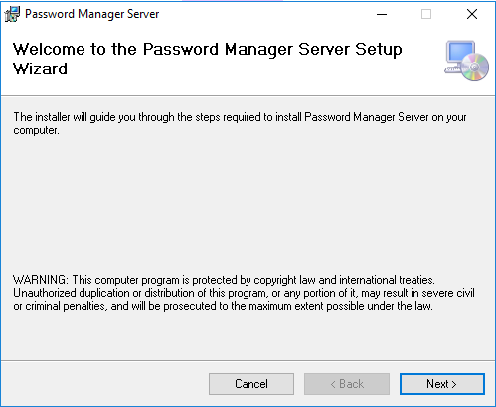

1. This should take just a few minutes to complete. You should receive a success message once complete.
2. From an elevated command window, switch to C:\Windows\Temp\ServerSetup and run ServerSetup.exe (this should take about a minute to complete):

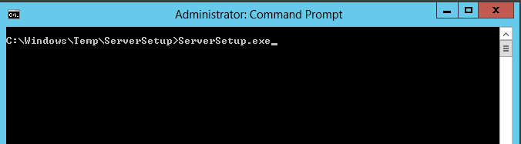

1. From the same elevated command window, run DBSetup.exe (this should take just a few seconds to complete):

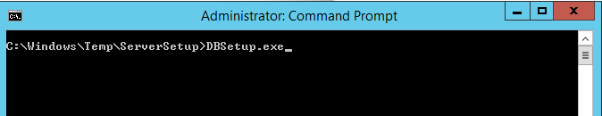

1. Installation is now complete.

From a web browser, go to the URL for the Console. The initial, non-SSL URL for the Password Manager console will be: http://<server-name>/console

For example, if installed on a server named passman06 in a domain named fryeware.com, your initial URL would be:

<http://passman06.fryeware.com/console>

1. The first visit to the Password Manager console will cause the server to build out the database schema, this results in the following error message:

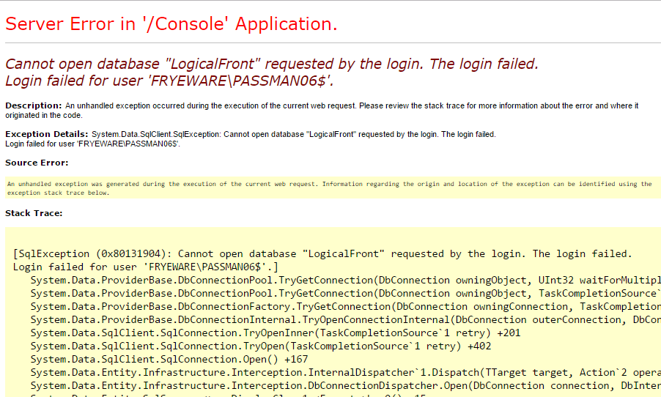

This error is due to a race condition as the database is not yet installed and will only occur on the **first** visit to the console web URL.

1. Refresh the page and you should see something similar to this indicating a successful server installation:

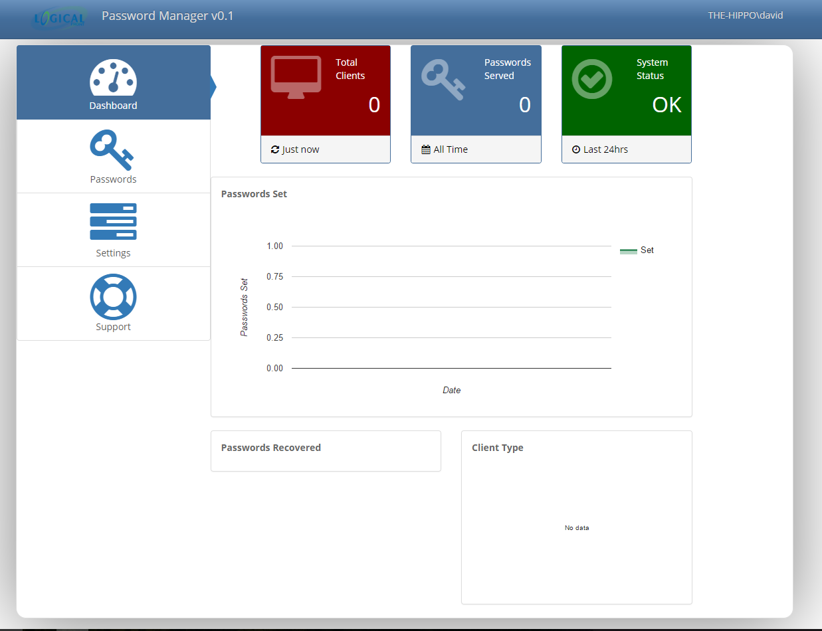

Note: no clients are yet installed so the dashboard widgets will not be reporting any data.

Very Important Note: You **should now** configure SSL for the web site within IIS. Your URL scheme would then transition from the http:// to https://

# Client Installation Instructions

## System Requirements:

* Windows 7 or newer
* .NET Framework 4.5.2 or newer
* Joined to an Active Directory domain
* The Password Manager install media available from the registered user Download page at the Fryeware web site: <https://www.fryeware.net>

## Procedure:

1. Download PMAgent.msi to a local directory on the server (our first Password Manager client will be the Password Manager server itself) and double click the PMAgent.msi to begin:

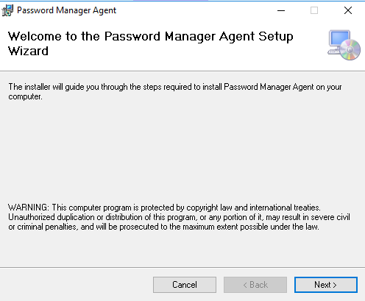

1. Enter the root URL for the server this agent will connect to:

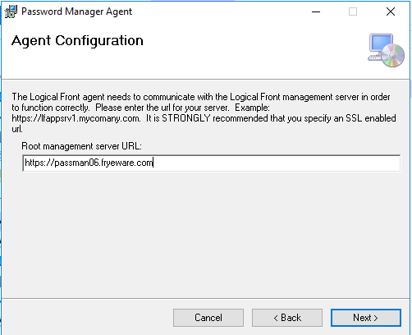

NOTE: you can also specify this option at the command line using the SERVICEURL property. This allows for mass deployment scenarios using GPO or other distribution tools. For example, to deploy PMAgent.msi silently and configure it to connect to a server named passman06.fryeware.com, you would use this command line:

msiexec.exe /i pmagent.msi SERVICEURL=https://passman06.fryeware.com /qn

1. Installation should take less than 1 minute, once complete go back to the Password Manager Console and verify that you see the 1st client reporting in:

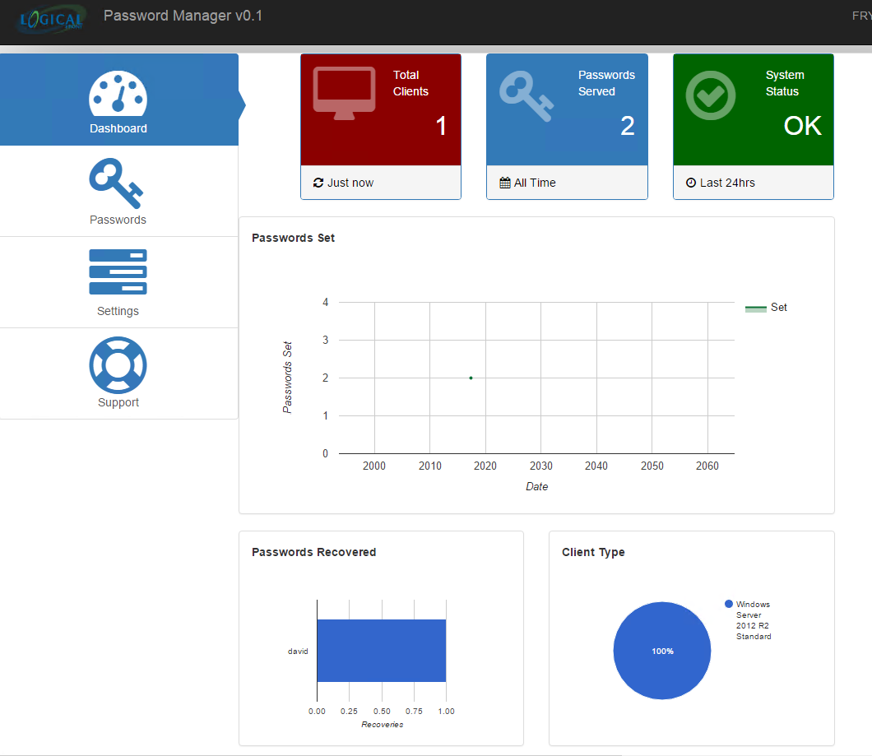

1. Do a password recovery for the client that you just installed:

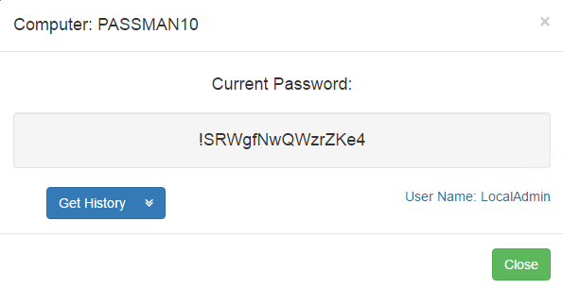

1. Verify that the password works. A suggested approach to this is to simply do a “Run as different user” for Command Prompt (cmd.exe) from the Windows shell and specify “.\LocalAdmin” as the user, then paste in the password from the recovery screen. If you see the cmd.exe program launch successfully, your installation of Password Manager is fully functional and ready for more clients.

